**ASSIGNMENT NO : 1**

**IBM(NALAIYA THIRAN)**

**TEAM MEMBER 3:MONIKAA R**

**REG NO:411719205028**

**EMAIL:monikaa.r.it@psvpec.in**

**TOPIC : SMART HOME**

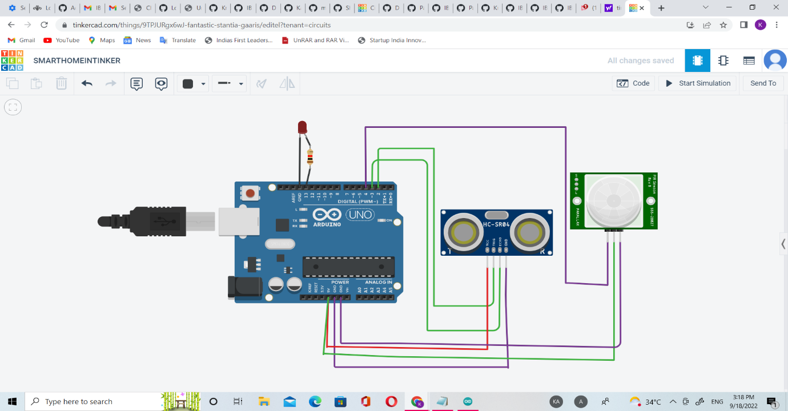

**TINKER CAD**

**CODE:**

**int trigger_pin=2;**

**int echo_pin=3;**

**int time;**

**int distance;**

**void setup()**

**{**

**Serial.begin(9600);**

**pinMode(trigger_pin,OUTPUT);**

**pinMode(echo_pin,INPUT);**

**pinMode(4,INPUT);**

**pinMode(13,OUTPUT);**

**}**

**void loop()**

**{**

**digitalWrite(trigger_pin,HIGH);**

**delayMicroseconds(10);**

**digitalWrite(trigger_pin,LOW);**

**time=pulseIn(echo_pin,HIGH);**

**distance=(time*0.034)/2;**

**if(distance<=10)**

**{**

**Serial.println("Door open");**

**Serial.print("Distance=");**

**Serial.println(distance);**

**delay(500);**

**}**

**else{**

**Serial.println("Door closed");**

**Serial.print("Distance=");**

**Serial.println(distance);**

**delay(500);**

**int p=digitalRead(4);**

**if(p)**

**{**

**digitalWrite(13,HIGH);**

**Serial.println("motion detected");**

**}**

**else**

**{**

**digitalWrite(13,LOW);**

**Serial.println("not detected");**

**}**

**}**

**}**